Number 283  Gaining Competitive Advantage with Data and Analytics  Editor/Publisher  Jim Marous, DBR Media, LLC  Issue  August 2021 — DBR 283  Cost: Individual Report: Complimentary; Enterprise-wide License: $1500  Part of subscription  Size  25 pages, 13 tables/charts  Ordering  Online at https://www.digitalbankingreport.com/dbr/dbr283  Email: admin@digitalbankingreport.com  By phone at: +1-216-218-4257 | 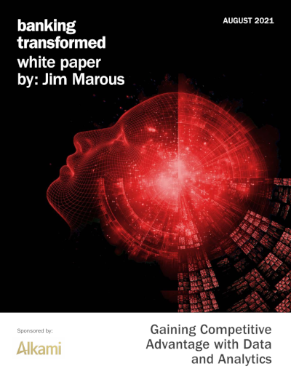  Sponsored by:

Abstract
Data and advanced analytics can provide a huge competitive advantage and source of growth for traditional and non-traditional financial services providers. Organizations with data and analytic maturity can provide hidden insights into the daily operations of organizations, helping them to come up with more efficient and productive ways of working — pricing risks, and predicting market trends.
Bottom line, data is the foundation for all components of digital transformation, with banks and credit unions increasingly recognizing that the organization-wide deployment of insights can add significant value to their businesses. The use of data must move beyond the creation of reports used by a few. To maximize the impact of data as a competitive advantage, access must be democratized.
The ability to instantly access and understand data will translate into faster decision making, and that will translate into more agile teams. Those teams will have a competitive advantage over slower data-stingy businesses.
In fact, when a financial institutions allows data access across an organization, it empowers individuals at all levels of ownership and responsibility to use the data in their decision making. Data democratization also creates team members that are more data-driven, which has a positive impact on customer experiences.
Understanding your organization’s analytics maturity helps you identify your strengths and weaknesses. From this understanding, you can start to create goals and a vision for supporting and improving usage of analytics (i.e., a roadmap).
Obviously, gaining the skills to improve data and analytics maturity is imperative. Simultaneous upskilling, while partnering with third-party solution providers will help organizations focus their efforts directionally to maximize their returns. When the organizations genuinely embrace the importance of the data maturity progression, the data and analytics initiatives will start falling in place accordingly.
We hope the insights contained within provide the basis for discussion and progress in the pursuit of data maturity. We would like to thank Alkami for their continued support of creating insights around all the components of digital banking transformation.

