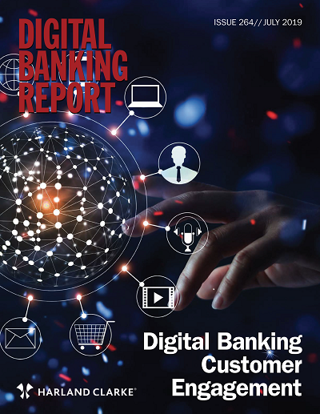

Sponsored by:

Number 264
Digital Banking Customer Engagement

Editor/Publisher
Jim Marous, DBR Media LLC

Issue
July 2019 — DBR 264
Cost: Individual report: $495; Enterprise-wide license: $1995;
Part of subscription

Size
71 pages, 32 tables/charts

Ordering
Online at
https://www.digitalbankingreport.com/dbr/dbr264/
Email: admin@digitalbankingreport.com
By phone at +1 216-218-4257

Abstract
The banking industry, similar to most industries, is in the midst of a customer engagement revolution. We are no longer evaluated based on how we have connected with consumers in the past, or how our direct banking industry competitors connect with consumers. We are judged by how the tech giants use data and advanced analytics to engage with consumers during the entire customer journey.
The good news is that new technologies allow financial institutions to engage with consumers in new and better ways, closely replicating the experiences provided by Amazon, Google, Facebook and other big tech firms. Going beyond a simplified digital account opening application, banks and credit unions can now engage with their consumers across multiple channels during the entire customer journey … in real time.
This allows financial institutions to proactively meet the following consumer engagement expectations:
- Understand what I want and need before I ask for it. And, protect me from situations that may negatively impact my financial well-being.
- Communicate with me on the channel(s) or device(s) that I prefer, even if it is different for different situations.
- Learn about me over time, and share what you learn with all areas of your organizations so I don’t need to repeat myself.
Now, more than ever consumers are completely in control. They share experiences on social platforms and expect a level of personalization never before possible. And the bar is rising fast in terms of what constitutes a ‘personalized’ experience. According to Salesforce, 62% of consumers now expect companies to adapt based on their actions, communications and behaviors.
Because of the seamless experience provided by leading non-banking firms, consumers are raising the bar for all other industries. If a bank or credit union doesn’t communicate in a personalized manner, at the best time of connection and on the desired channel, the shortfall is more obvious than ever.
“Convenience and ease are the pillars for a great engagement and AI can supercharge them all,” said David Clarke, Global Chief Experience Officer, PwC. “Success lies in delivering experiences that are personalized, real-time, and connected.“
All of these changes are prompting financial institutions to rethink how they engage and connect with consumers. By providing personalized, real-time, and consistent communication throughout the customer journey, banks and credit unions can find new ways to engage their customers and members. Just as importantly, financial institutions that respect consumer data, and use it well to improve their experience, stand a better chance of increasing trust and building loyalty.
We would like to thank Harland Clarke who sponsored this research on digital customer onboarding and engagement. Their partnership enabled us to continue to do the most comprehensive trend analysis in the banking industry.
This year’s report provides a perspective of where digital engagement in financial services is today and where it may be tomorrow. More importantly, this report provides the foundation for financial executives to create a customer experience similar to what is provided by big tech leaders.

